Week 5 - Lab: Build "Hello World" Django App

Install Django

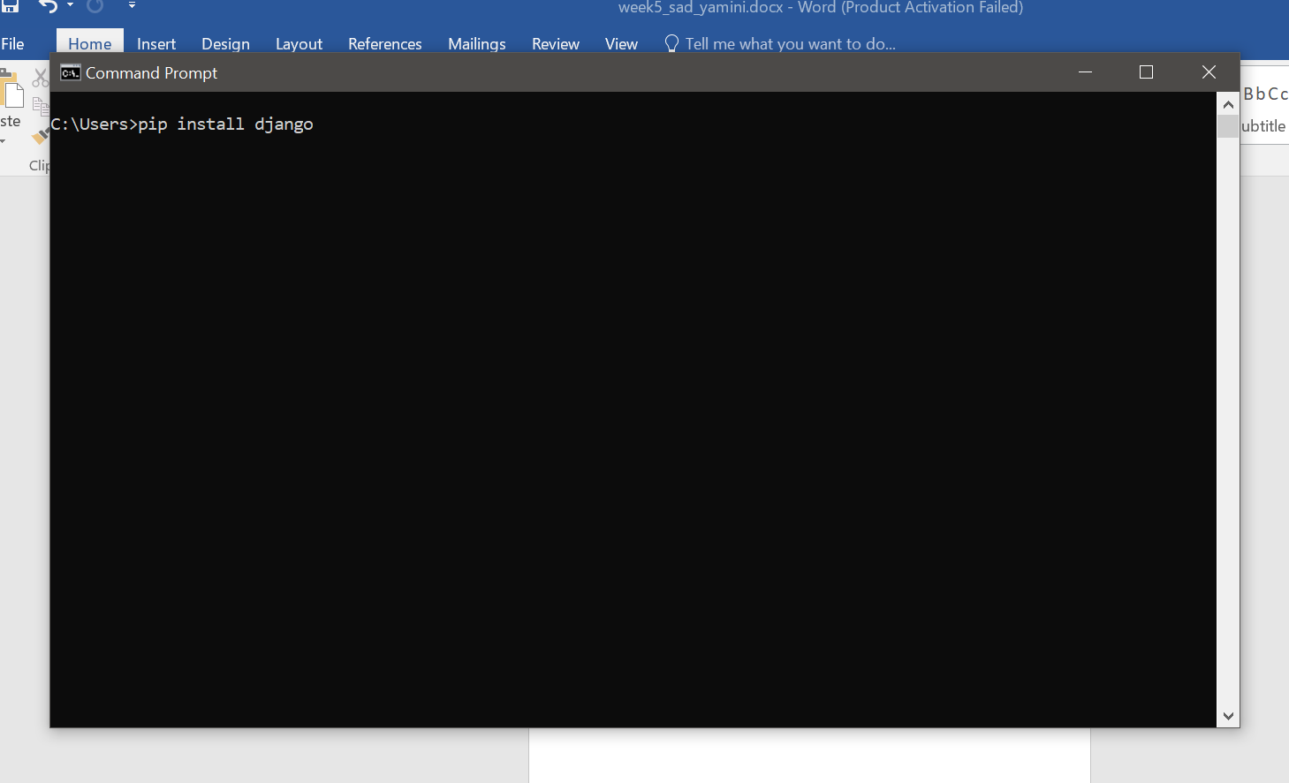

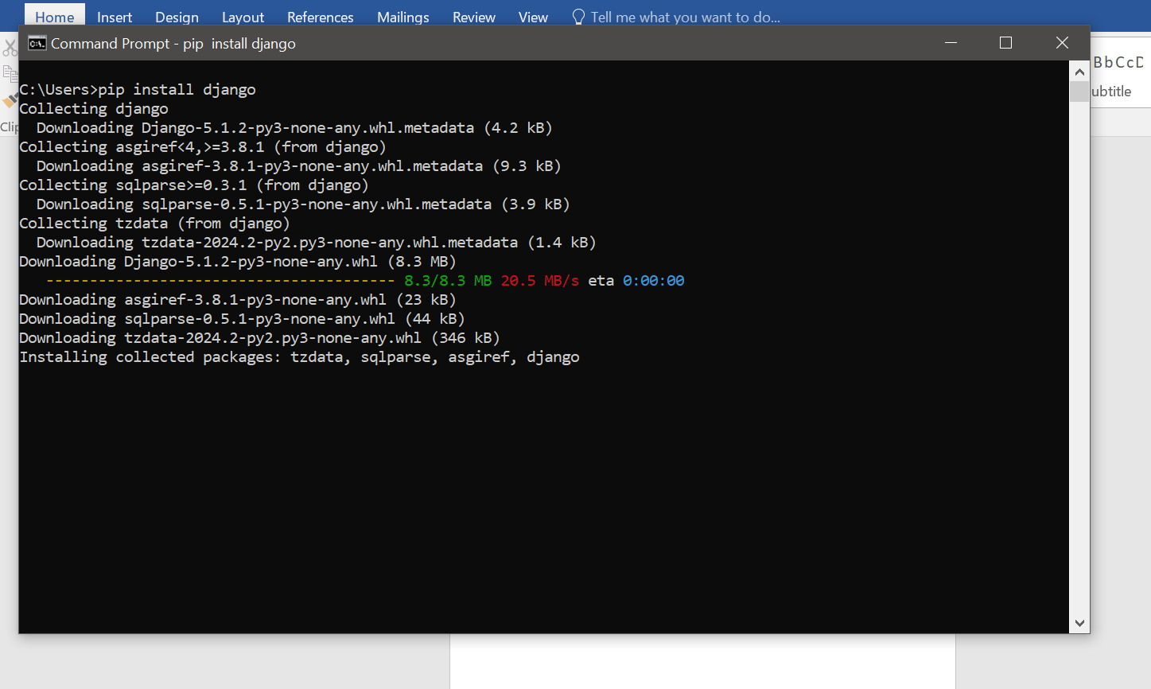

**Create a Django Project**: Open your terminal and run:

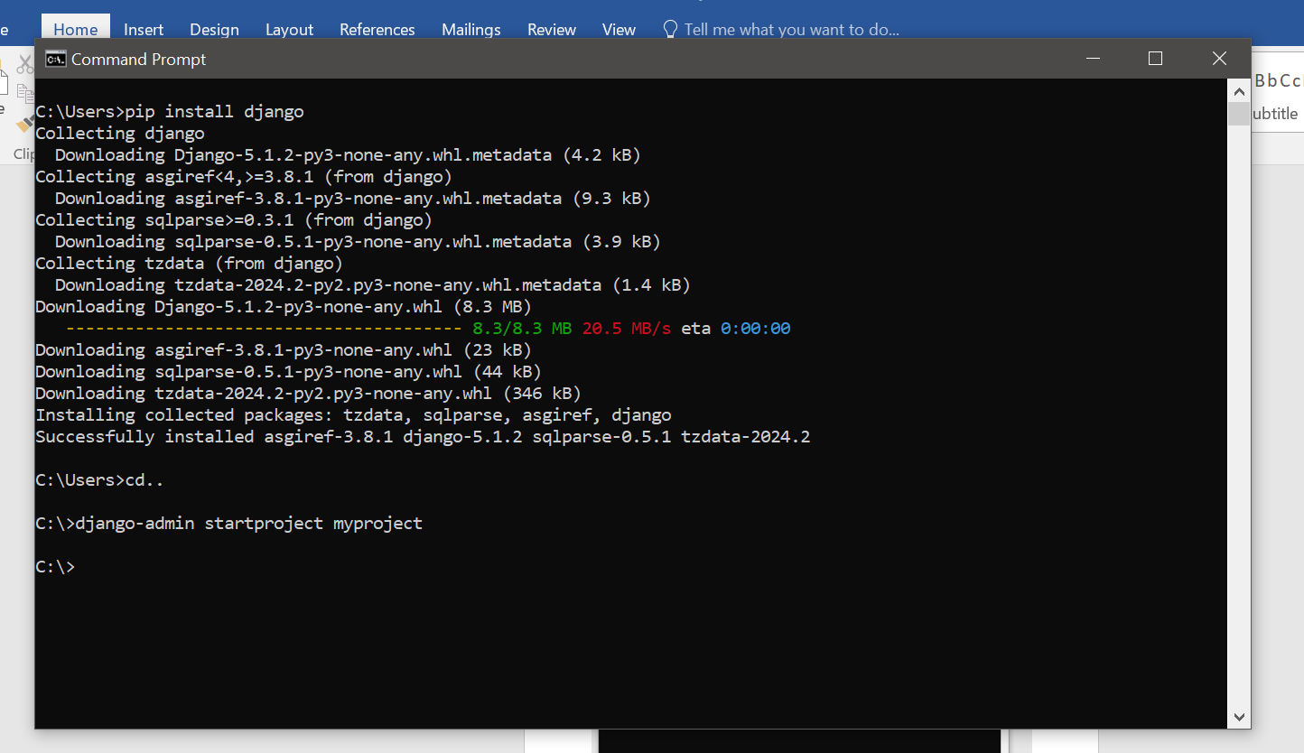

**Create a New App**: Inside the myproject directory, run:

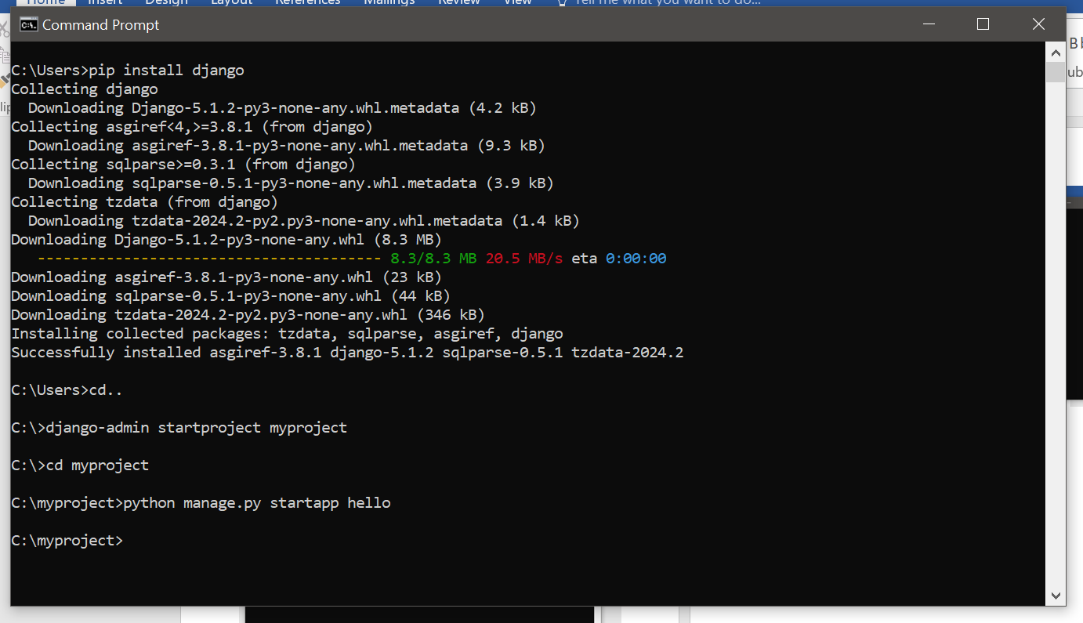**Register the App**: Open myproject/settings.py and add 'hello' to the INSTALLED_APPS list:

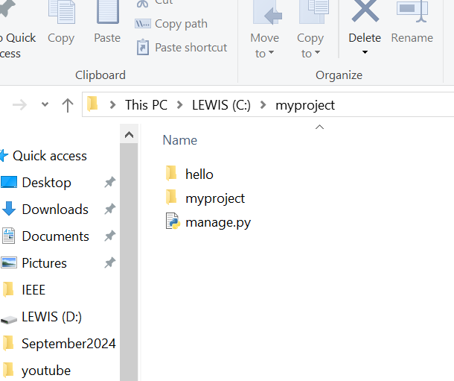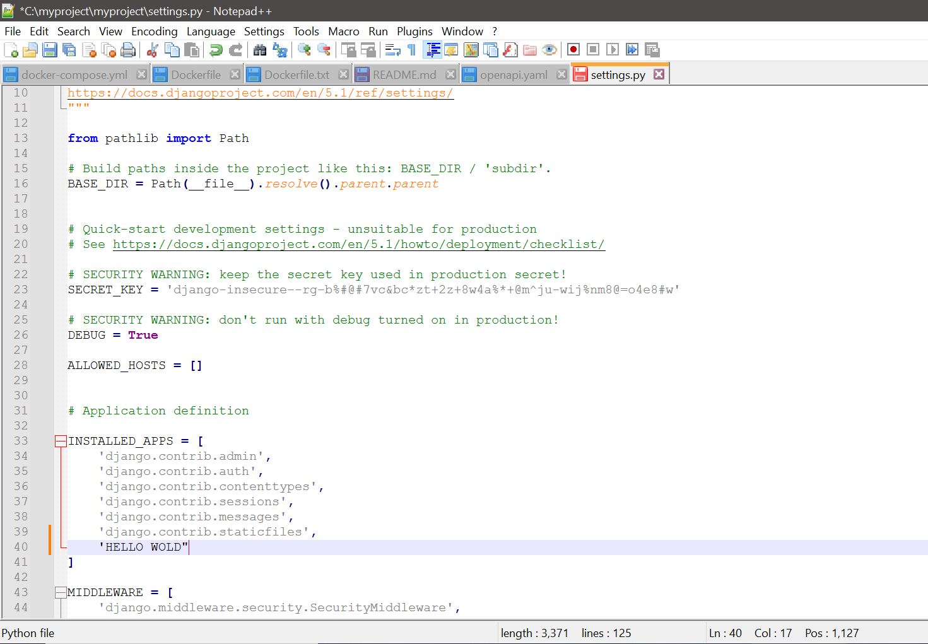

Define the View: Open hello/views.py and add the following function:

Create a URL for the View: Create a new file hello/urls.py and add:

Include the App’s URLs in the Project: Open myproject/urls.py and include the app’s URLs:

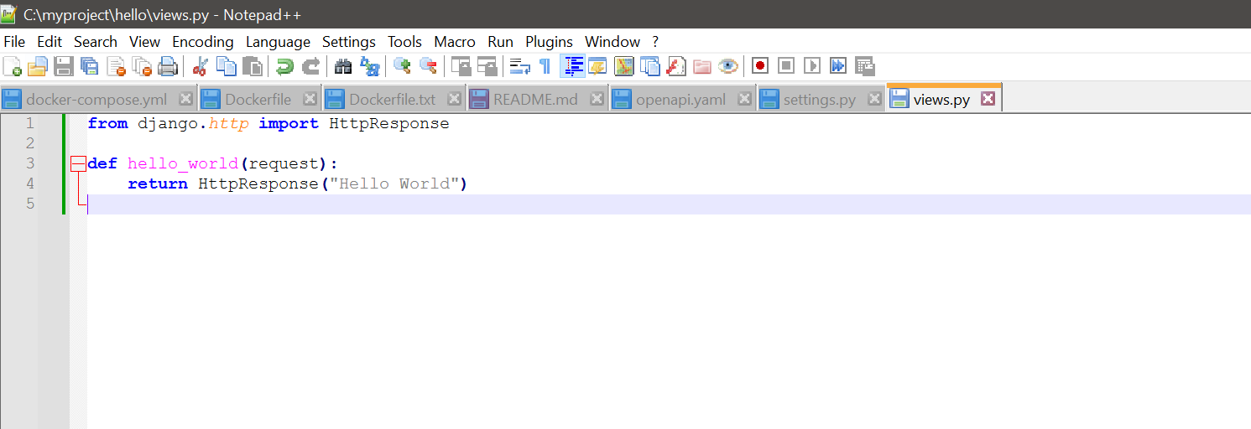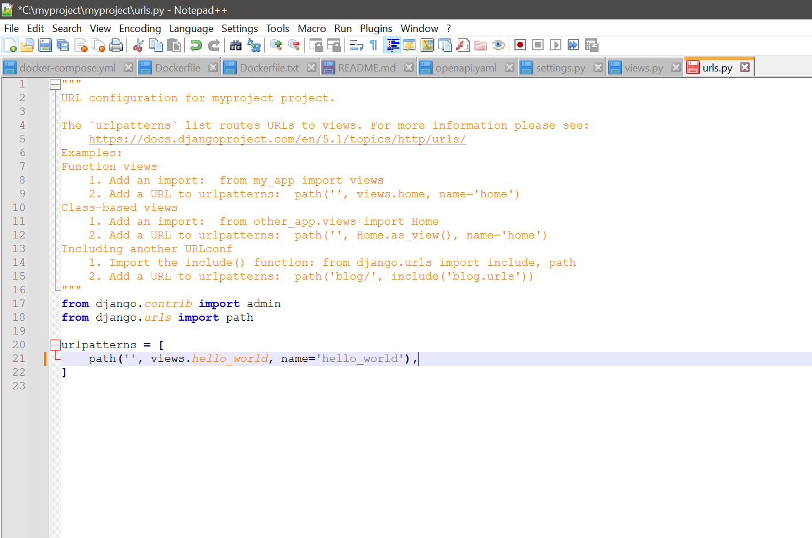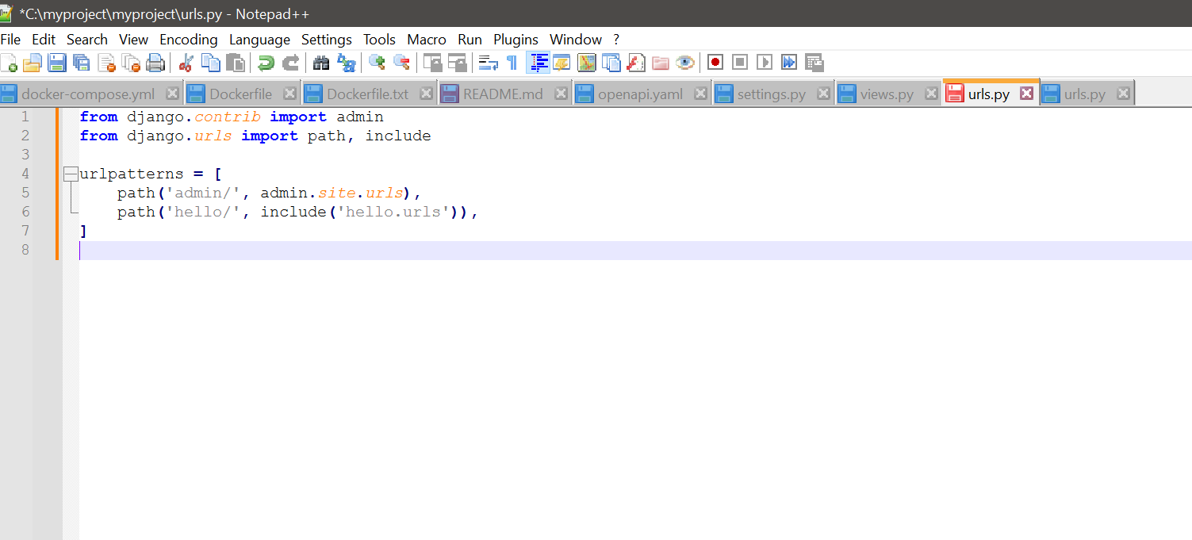

Run the Django Server

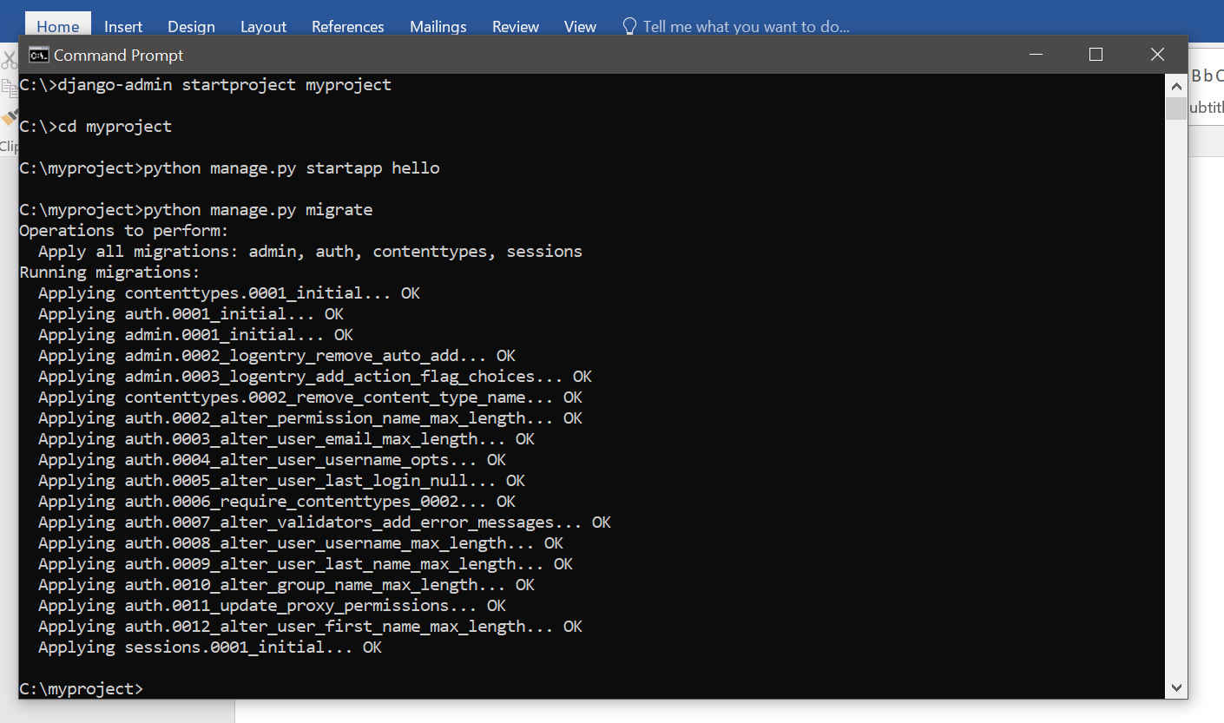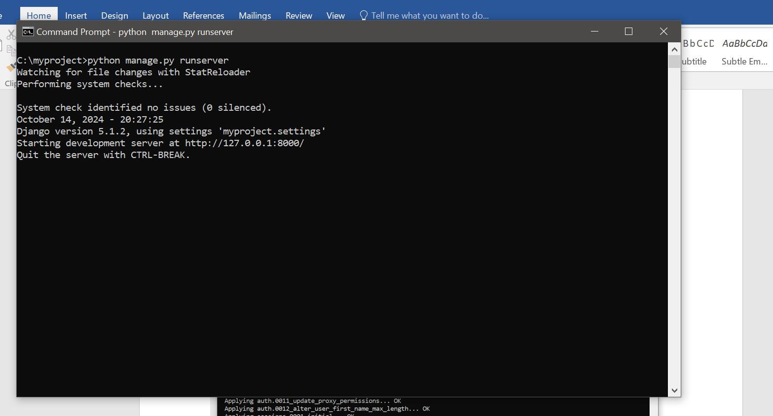

**Access the Application**: Open your web browser and go to http://127.0.0.1:8000/hello/. You should see "Hello World" displayed on the page!

